Software Design & Architecture

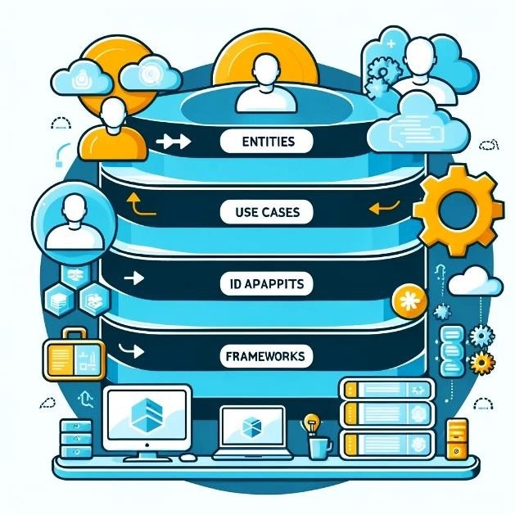
Project Report

Group Members:
- Huzaifa Ali 242277
- M.Daim Rasheed 242202
- M. Usman 242197

Class: BsSE – 4A

Deadline: May 31,2026
Project Title:

Online Shopping System
Abstract:
The Online Shopping System is a modular, console-based e-commerce application developed in C++. It supports customer purchasing, admin inventory management, and secure payments. Designed using key software design patterns, the system emphasizes scalability, maintainability, and clear architecture, serving as a practical model for user-friendly online shopping.

Submitted To: Ms. Summan Aziz

Online Shopping System

Table of Contents
- Introduction 2
- Architectural Goals and Constraints 2
- High-Level Architecture Overview 3
- Application of SOLID Principles 5
- Technology Stack 6
- Component Design 7
- Design Patterns Applied 9
- Data Design 14
- Security and Performance Considerations 15
- Deployment Architecture 15
- Conclusion 15

Software Design and Architecture (SDA) Project Report

Project Title:
Online Shopping System

Introduction

Project Overview:
This project is an Online Shopping System designed to simulate a real-world e-commerce platform. It enables Admins to manage inventory and Users to browse products, add them to the cart, and perform checkout using different payment methods. It also includes internal logging, notifications, and payment gateway integrations. The system is designed to showcase software design patterns and principles for scalability, maintainability, and extensibility.

Scope and Purpose:
The architecture is designed to be modular, object-oriented, and pattern-driven, showcasing the practical implementation of several GoF design patterns for clarity, maintainability, and extensibility. The system emphasizes an efficient flow for users to interact with the platform and admins to manage products and orders.

Architectural Goals and Constraints

Key Quality Attributes:
  - Maintainability: The code is modular with clear responsibilities for each class, making it easy to maintain and extend.

  - Scalability: The system is designed to easily support new payment methods or checkout strategies without significant changes to the underlying architecture.
  - Reusability: It uses standard design patterns such as Factory, Command, and
Strategy, which promote code reuse across different parts of the system.
  - Simplicity: A console-based user interface simplifies the interaction and focuses on core functionalities.

Constraints:
  - Implemented in C++: The system is implemented using C++ to take advantage of its performance and efficiency in handling system resources.
  - Console-based user interface: While functional, the UI is basic and text-based, designed primarily for core feature demonstration.
  - In-memory data management: The system does not use persistent storage (no databases or file persistence). Data is held temporarily in memory, which can limit scalability.

High-Level Architecture Overview

Architectural Style:
The system follows a Layered Architecture, separating the concerns of presentation, business logic, and data handling:
  - Presentation Layer: Handles the console-based user interface (menus for Admin/User).
  - Application Layer: Contains the business logic (checkout, cart management, commands).
  - Data Layer: In-memory storage using arrays for managing product inventory and cart items.

System Context:
Two primary actors interact with the system:
  - Admin: Manages product inventory and payment method configurations.
  - User: Browses available products, adds them to the cart, and completes the checkout process.

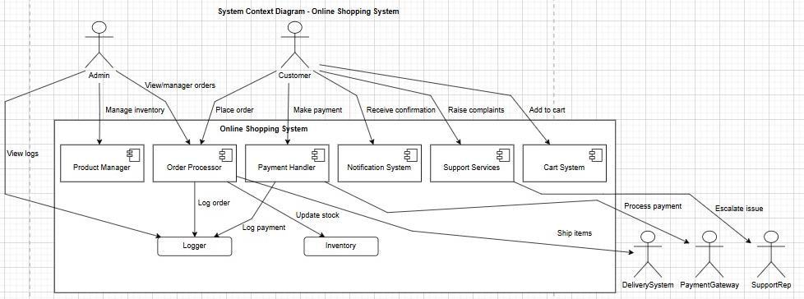
Two actors (Admin and User) interact with the system to manage products and place orders respectively.

Component Diagram:

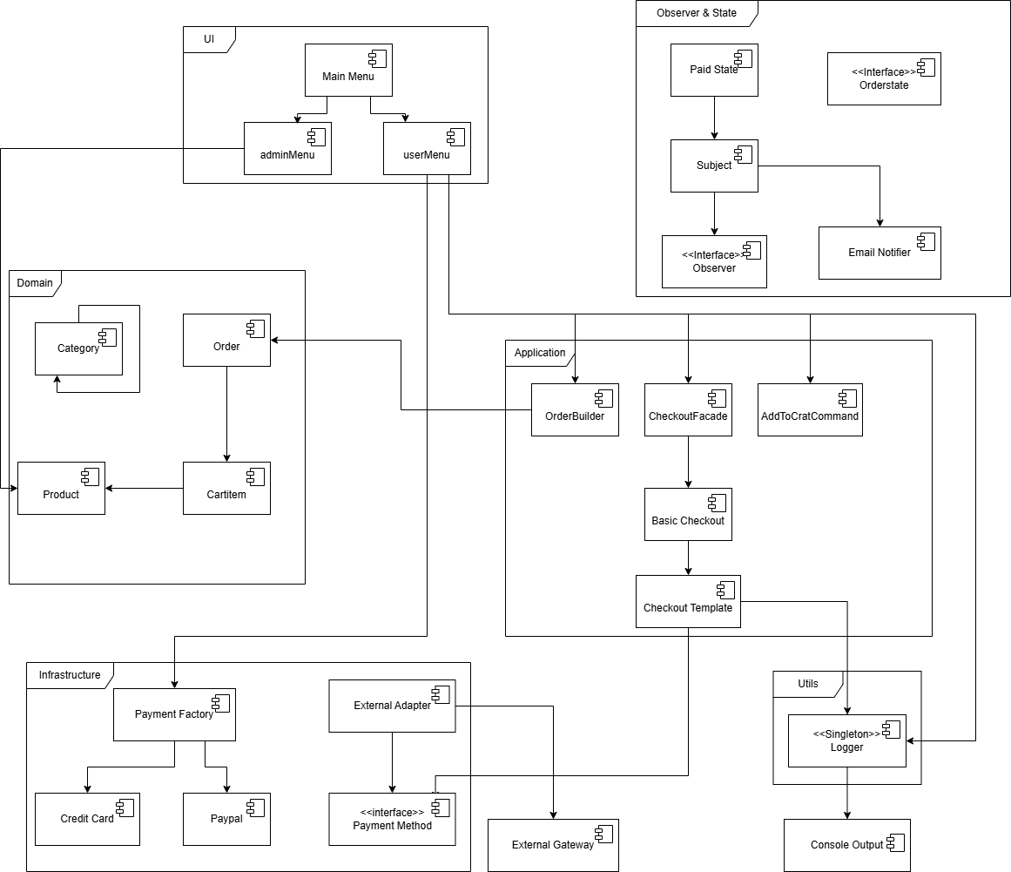
Application of SOLID Principles

SRP (Single Responsibility Principle):
Each class has a focused responsibility. For example, the Logger class is responsible for logging, and CartItem represents the items in the cart.

Copy:
class Logger { private:
static Logger* instance; Logger() {}
public:
static Logger* getInstance() {
if (!instance) instance = new Logger(); return instance;
}
void log(string msg) {
cout << "[LOG]: " << msg << endl;
}
};

OCP (Open/Closed Principle):
The system is open for extension but closed for modification. New payment methods can be added through subclassing without altering existing classes.

Copy:
class PaymentMethod { public:
virtual void pay(double amount) = 0; virtual ~PaymentMethod() {}
};

class CreditCard : public PaymentMethod { public:
void pay(double amount) override {
cout << "Paid $" << amount << " via Credit Card.\n";
}
};

LSP (Liskov Substitution Principle):
Derived classes such as CreditCard, PayPal, and ExternalAdapter can be used interchangeably in place of the PaymentMethod class.

Copy:
class ExternalAdapter : public PaymentMethod { ExternalGateway* gateway;
public:
ExternalAdapter(ExternalGateway* g) : gateway(g) {} void pay(double amt) override {
gateway->externalPay((float)amt);

}
};

ISP (Interface Segregation Principle):
The system defines clear and focused interfaces. For example, Observer handles notifications and Command handles cart actions.

Copy:
class Observer { public:
virtual void update(string msg) = 0;
};

class Command { public:
virtual void execute() = 0;
};

DIP (Dependency Inversion Principle):
The CheckoutFacade depends on the abstraction PaymentMethod, allowing for flexible, interchangeable payment strategies.

Copy:
class CheckoutTemplate { public:
void checkout(Order order, PaymentMethod* pmt) { order.display();
applyDiscount(order); pay(order, pmt);
}
virtual void applyDiscount(Order& o) { /* ... */ } virtual void pay(Order& o, PaymentMethod* pmt) = 0;
};

Technology Stack
The Online Shopping System is built with a robust technology stack that ensures efficient execution, modularity, and ease of extensibility.

Language:
  - C++: Chosen for its high performance, control over system resources, and suitability for creating efficient, console-based applications. C++ provides low-level access to memory, making it ideal for handling dynamic systems like inventory management and checkout flows with minimal overhead.

Libraries:
  - Standard C++ Libraries:
    - iostream: Used for input and output operations, essential for creating the console-based interface.
    - string: Essential for managing product names, user input, and other string- related operations.
    - Standard Template Library (STL): Utilized for handling arrays and other data structures efficiently.

Development Tools:

  - Visual Studio Code: A versatile, lightweight code editor that supports C++ development with useful extensions and debugging tools.
  - Code::Blocks: Used for compiling and testing the C++ code, offering an easy-to-use environment for managing large codebases and debugging.

Other Technologies:
  - Static Arrays: The use of static arrays (MAX_PRODUCTS, MAX_CART) ensures predictable performance and easy data access, although it limits scalability for larger data sets.

Future Technology Considerations:
  - Database Integration (SQLite/PostgreSQL): In the future, integrating a database management system for persistent storage would allow for better scalability and data integrity. A database would allow products, orders, and user information to be stored and managed more effectively.
  - Web-based Frontend: A transition to a React or Vue.js based frontend would make the system more interactive and user-friendly.

Component Design
The Online Shopping System is structured around key components that handle specific responsibilities, ensuring a modular and maintainable design. Each component is responsible for a well-defined task, adhering to the Single Responsibility Principle (SRP), and is designed to interact efficiently with other components.

Key Components and Responsibilities:
- Logger:
The Logger class is a Singleton that ensures centralized logging throughout the system. It is responsible for logging messages related to various system operations such as user actions, errors, and system events.

Product & CartItem:
The Product and CartItem classes manage the core functionality of inventory and shopping cart operations:
  - Product: Represents a product in the inventory, holding details like product name, price, and stock quantity.
  - CartItem: Represents an item added to the shopping cart, including quantity and the associated product.

Command (AddToCartCommand):
The AddToCartCommand class encapsulates the action of adding a product to the cart. It allows for easy extension of additional commands related to cart operations in the future, promoting loose coupling between the user interface and the underlying logic.

PaymentMethod Hierarchy:
The PaymentMethod class defines an abstract class for all payment methods. It is extended by various concrete classes like CreditCard, PayPal, and ExternalAdapter, enabling polymorphism for handling different payment methods in a seamless manner.
  - Factory: The PaymentFactory class creates instances of the appropriate payment method.

Order & OrderBuilder:
  - Order: Represents a complete order, including the customer’s details, cart
items, and the total price.
  - OrderBuilder: Provides a flexible way to build an Order step-by-step. It separates the construction process from the order details, allowing for easier modifications and improvements.

Observer (EmailNotifier):
The Observer pattern is applied through the EmailNotifier class, which receives updates regarding order status changes. It decouples the notification mechanism from the core order processing logic, allowing for easy addition of new notification methods (e.g., SMS notifications) in the future.

OrderState:
The OrderState class and its subclasses (e.g., PaidState) define the lifecycle states of an order (e.g., paid, shipped). This pattern allows the order's state to change dynamically without altering the core order processing code.

CheckoutTemplate:
This class defines the standard checkout flow. It applies any discounts (via the
applyDiscount method) and handles the payment logic (via the pay method), using the

Template Method pattern. Specific checkout processes are customized by subclassing this template (e.g., a premium checkout flow).

Category:
The Category class is used to organize products into categories in a hierarchical manner. It allows categories to be nested within other categories, forming a tree structure, thanks to the Composite pattern. This is useful for large catalogs with complex categorizations.

Interactions:
- Users interact with the system by browsing products, adding items to their cart, and proceeding with checkout.
- Admin users manage the inventory, adding or removing products, and configuring payment methods.
- The Cart and Checkout processes interact through the Command pattern to add items to the cart and finalize the purchase.
- Payment is handled through polymorphic method calls to the appropriate payment method (CreditCard, PayPal, etc.), ensuring extensibility for additional payment options in the future.
- The Observer pattern ensures that notifications (e.g., emails) are triggered upon order state changes, such as when an order is marked as paid.
The Facade pattern, represented by the CheckoutFacade class, simplifies the interaction between the complex subsystems of payment processing, logging, and notification, presenting a single interface for the user to complete their order.

Design Patterns Applied
The design of the Online Shopping System incorporates several key Gang of Four (GoF) design patterns, which play a crucial role in promoting code modularity, scalability, and maintainability. The following patterns are employed:

Singleton:
Pattern Usage: The Logger class ensures that only one instance of the logging service exists throughout the system, simplifying the process of logging messages.

Code:
class Logger { private:
static Logger* instance; Logger() {}

public:
static Logger* getInstance() {
if (!instance) instance = new Logger(); return instance;
}
void log(string msg) {
cout << "[LOG]: " << msg << endl;
}
};

Factory Method:
Pattern Usage: The PaymentFactory creates instances of different payment methods (e.g., CreditCard, PayPal) based on user input. This allows new payment methods to be added without modifying existing code.

Code:
class PaymentFactory { public:
static PaymentMethod* create(string type) {
if (type == "CreditCard") return new CreditCard(); else if (type == "PayPal") return new PayPal(); return NULL;
}
};

Builder:
Pattern Usage: The OrderBuilder class constructs the Order object step by step, allowing for more flexible order creation without directly manipulating the Order class itself.

Code:
class OrderBuilder { private:
Order order; public:
void setCustomer(string name) { order.customer = name; } void buildTotal() {
order.total = 0;
for (int i = 0; i < cartCount; i++) order.total += cart[i].getTotal();
}
Order getOrder() { return order; }
};

Strategy:
Pattern Usage: The ShippingStrategy allows the system to choose different shipping methods dynamically. It provides flexibility to change shipping strategies without affecting other parts of the system.

Code:
class ShippingStrategy { public:
virtual string method() = 0;
};

class StandardShipping : public ShippingStrategy

{

public:
string method() { return "Standard Shipping"; }
};

Command:
Pattern Usage: The AddToCartCommand encapsulates the action of adding a product to the cart, promoting loose coupling between the user interface and the business logic.

Code:

class AddToCartCommand : public Command { int id, qty;
public:
AddToCartCommand(int i, int q) : id(i), qty(q) {} void execute() {
if (id > 0 && id <= productCount && inventory[id - 1].stock >= qty) {
cart[cartCount++] = CartItem(inventory[id - 1], qty); inventory[id - 1].stock -= qty;
Logger::getInstance()->log("Item added to cart.");
}
}
};

Observer:
Pattern Usage: The Observer pattern is used to notify users (via EmailNotifier) when an order has been marked as paid. It decouples the order processing logic from the notification logic.

Code:

class Observer { public:
virtual void update(string msg) = 0;
};

class EmailNotifier : public Observer { public:
void update(string msg) {
cout << "[Email] " << msg << endl;
}
};

State:

Pattern Usage: The OrderState pattern allows an order to transition through different states (e.g., "Paid") without changing the order management logic.

Code:
class OrderState { public:
virtual void handle(Subject* s) = 0;
};

class PaidState : public OrderState { public:
void handle(Subject* s) {
s->notify("Order marked as PAID.");
}
};

Template Method:
Pattern Usage: The CheckoutTemplate defines a standard checkout process, which can be extended by different checkout types (e.g., basic checkout, premium checkout).

Code:
class CheckoutTemplate { public:
void checkout(Order order, PaymentMethod* pmt) { order.display();
applyDiscount(order); pay(order, pmt);
}
virtual void applyDiscount(Order& o) { /* ... */ } virtual void pay(Order& o, PaymentMethod* pmt) = 0;
};

Facade:
Pattern Usage: The CheckoutFacade simplifies the interaction between various complex subsystems (payment, order handling, logging) and presents a single interface to the user.

Code:
class CheckoutFacade { public:
void complete(Order order, PaymentMethod* payment) { BasicCheckout process;
process.checkout(order, payment); Logger::getInstance()->log("Order complete.");
}
};

Adapter:
Pattern Usage: The ExternalAdapter allows external payment systems to integrate with the
system’s payment infrastructure without modifying existing code.

Code:
class ExternalAdapter : public PaymentMethod { ExternalGateway* gateway;
public:
ExternalAdapter(ExternalGateway* g) : gateway(g) {} void pay(double amt) override {
gateway->externalPay((float)amt);
}
};

Composite:
Pattern Usage: The Category class allows for a tree structure of product categories, enabling flexible hierarchical management.

Code:
class Category { string name;
Category* children[3]; int count = 0;
public:
Category(string n) : name(n) {}
void add(Category* c) { if (count < 3) children[count++] = c;
}
void display(string prefix = "") { cout << prefix << name << endl;

for (int i = 0; i < count; i++) children[i]-
>display(prefix + " ");
}
};

Data Design
  - Product Inventory: Fixed-size array (MAX_PRODUCTS)
  - Cart Items: Stored in a global array (MAX_CART)
  - Order Data: Stored in temporary objects via builder
Note: All data resides in memory. No file/database persistence is used.
ERD
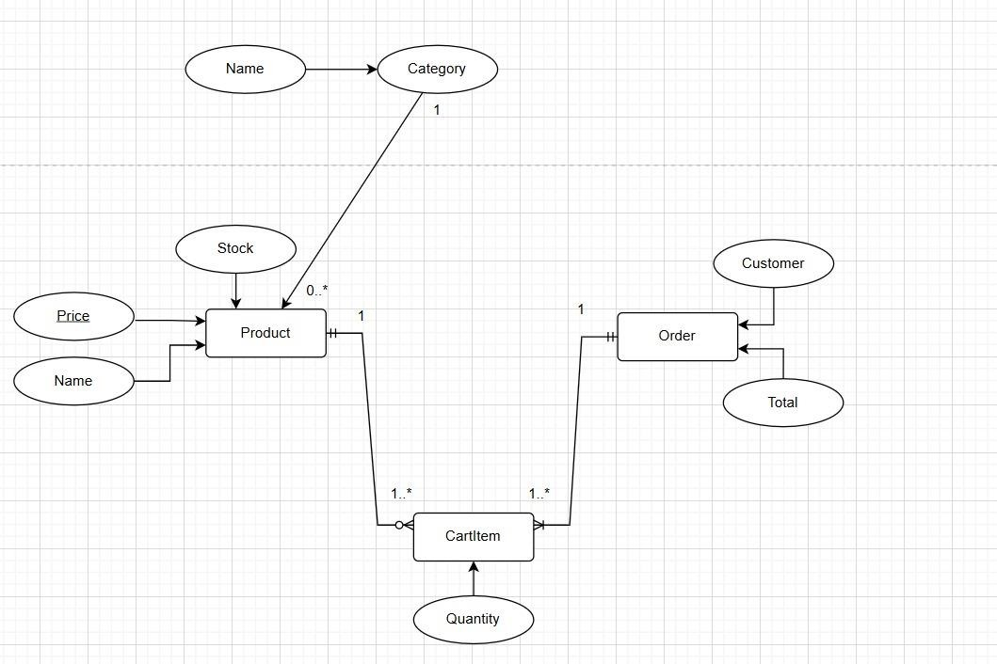

Security and Performance Considerations

Security:
  - Admin access is password-protected to prevent unauthorized access.
  - User access control ensures that users cannot modify system data such as inventory or orders.

Performance:
  - The system utilizes static arrays for data storage, ensuring fast, predictable access and no dynamic memory overhead beyond polymorphic allocations.
  - Logging operations are minimal, with the Logger class ensuring lightweight console- based logging without heavy resource consumption.
  - No dynamic memory bloat except singleton and polymorphic allocations

Deployment Architecture
  - The system runs on a single-threaded local machine and can be compiled with any standard C++ compiler.
  - The system’s design is platform-agnostic, requiring only a C++ compiler with standard libraries for execution. And no dependencies beyond standard headers
  - Future extensions could include integration with file-based storage systems or networked architectures for scaling the system in a production environment.

Conclusion

Summary:
The Online Shopping System presents a modular, maintainable, and extensible design using object-oriented principles and design patterns such as Singleton, Factory, and Strategy. The system demonstrates an efficient flow for both users and admins, leveraging SOLID principles for a clean and adaptable architecture. The architecture is designed with future growth in mind, allowing for easy integration of new features, such as additional payment methods or shipping strategies.

Limitations:
  - Persistence: The current system uses in-memory storage, which is limited in scalability for larger datasets.
  - User Interface: The console-based UI is functional but minimal, restricting user engagement and interaction.
  - Product/Category Management: The product and category management is currently static, and dynamic features like real-time updates or advanced filtering would be necessary for larger-scale e-commerce platforms.

Future Improvements:
  - Database Integration: Integrate a relational database such as SQL or
PostgreSQL for persistent storage and scalability.
  - Web or Mobile Frontend: Transition from a console interface to a web-based frontend or mobile application to enhance user experience and accessibility.
  - Advanced Features: Implement product search, dynamic filtering, and user profiles to enhance user engagement and convenience.
  - Security Enhancements: Introduce data encryption, two-factor authentication (2FA), and OAuth for secure user and admin access.
  - Performance Optimization: Refactor the in-memory management and improve data handling for better performance with larger datasets.
  - Extend Observer and Strategy patterns for analytics, shipping, etc.
In conclusion, the Online Shopping System provides a solid foundation for an e-commerce platform, and its potential for growth and improvement is vast. By implementing these suggestions, the system could evolve into a fully-fledged, scalable, and user-friendly solution suitable for modern e-commerce needs.

The End !

